HOW TO BUILD THE MAST

# LICENSE

Copyright (c) <2016>, <Plymouth University and the CHAP team1>

All rights reserved.

This license covers a Package to build a Low cost tele-operated mobile manipulator (CHAP) including: Designs for parts of the CHAP robot, Instructions for assembling said parts, and multiple Software systems. The Package is published with the aim of making Low-Cost Tele-operated Mobile Manipulators available to those who need them most: Disabled and Elderly people. The package should enable technically skilled individuals to build the robot. We encourage individuals and organizations to improve the contents of this Package, and share improvements under the same license. It is desirable for businesses to provide components or fully assembled robots to as many users as possible. Therefore, this package is released under the permissive FreeBSD (BSD 2-clause license) below:

Redistribution and use in source and binary forms, with or without modification, are permitted provided that the following conditions are met:

1. Redistributions of any elements of the package must retain the above copyright notice, this list of conditions and the following disclaimer.

2. Redistributions in binary form must reproduce the above copyright notice, this list of conditions and the following disclaimer in the documentation and/or other materials provided with the distribution.

THIS PACKAGE IS PROVIDED BY THE COPYRIGHT HOLDERS AND CONTRIBUTORS "AS IS" AND ANY EXPRESS OR IMPLIED WARRANTIES, INCLUDING, BUT NOT LIMITED TO, THE IMPLIED WARRANTIES OF MERCHANTABILITY AND FITNESS FOR A PARTICULAR PURPOSE ARE DISCLAIMED. IN NO EVENT SHALL THE COPYRIGHT OWNER OR CONTRIBUTORS BE LIABLE FOR

ANY DIRECT, INDIRECT, INCIDENTAL, SPECIAL, EXEMPLARY, OR CONSEQUENTIAL DAMAGES (INCLUDING, BUT NOT LIMITED TO, PROCUREMENT OF SUBSTITUTE GOODS OR SERVICES; LOSS OF USE, DATA, OR PROFITS; OR BUSINESS INTERRUPTION) HOWEVER CAUSED AND ON ANY THEORY OF LIABILITY, WHETHER IN CONTRACT, STRICT LIABILITY, OR TORT (INCLUDING NEGLIGENCE OR OTHERWISE) ARISING IN ANY WAY OUT OF THE USE OF THIS PACKAGE, EVEN IF ADVISED OF THE POSSIBILITY OF SUCH DAMAGE.

The views and conclusions contained in the Package are those of the authors and should not be interpreted as representing official policies, either expressed or implied, of the FreeBSD Project.

1 The CHAP team as of 14 November 2016 comprises: Guido Bugmann, Dominic Cassidy, Arunaganesan Swaminathan, Khushdeep Singh Mann.

Contents

LICENSE 1

Introduction 3

1. Mast wooden parts + top pulley 4

2. Rails 7

3. Cable holders 8

4. Mast base holder 12

Arm movement limiters 12

5. Lifting mechanism 13

Dual pulley 14

Shaft 14

Inner Ball Bearing 14

# Introduction

This instruction set outlines the building and assembly of the CHAP mast.

Note: All the parts lengths correspond to a mast height of 1625 mm. They can be adapted to another height. Think carefully if you do that.

# Mast wooden parts + top pulley

The mast has a U-profile mode of a front wooden bar of approximately 20x70x1625mm[1].

There are two side panels of plywood of 1606x100x5mm (left side) and 1530x100x5mm (right side). (Fig 1.1). The right panel is shorter to create space for the lifting mechanism (Fig 1.2).

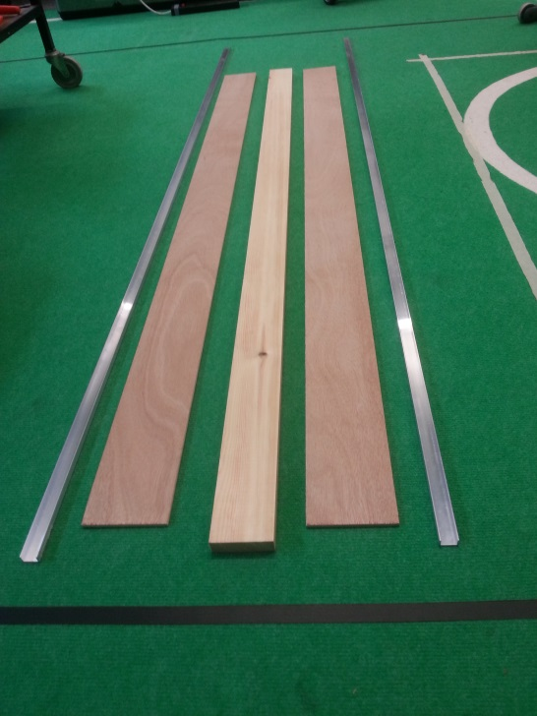

Figure .1 - Mast structural components.

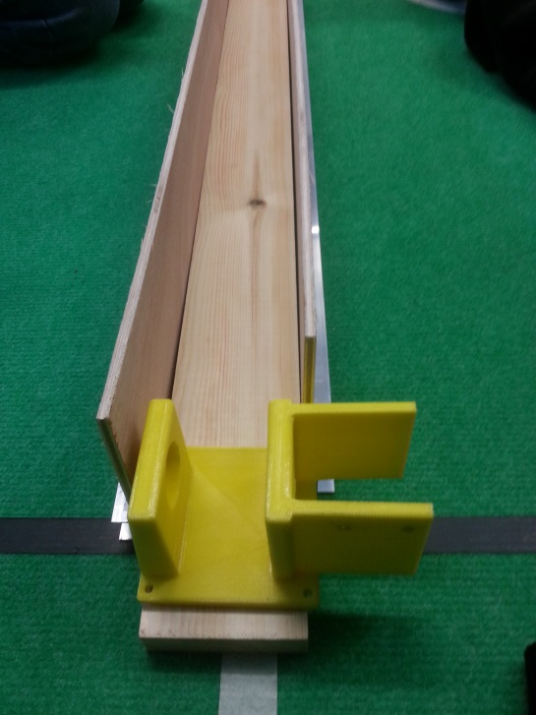

Figure 1. - Mast with motor holder.

The top of side boards have a rounded back for aesthetic reasons. Use a small round object, e.g. a trophy ☺ (Fig 1.3) to mark the shape to cut.

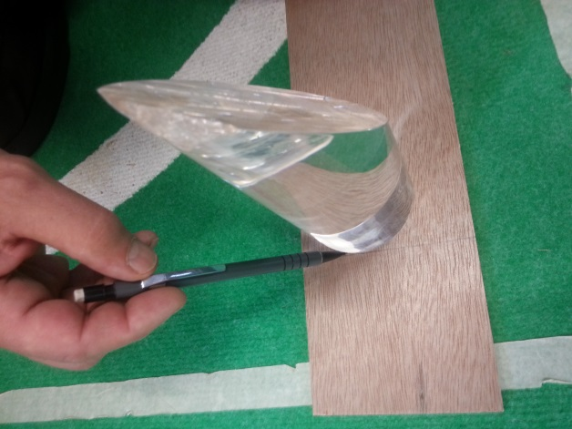

Figure 1.3 – Marking rounded shape.

Advice: It is a good idea to start with sidewalls longer than the final length. This makes it easier to cut the rounded part at the top and end with the top line (or the other way around).

Use a small number of 16mm x 3.5mm wood screws (e.g. 3 on each side) to hold the sidewalls in place on the central bar. Make sure that positions of the screws are different from those in the rails to avoid collision (see Fig 1.5). The real strong attachment will come from the screws used to attach the rails. Drill small 2mm pre-holes.

The top of the mast holds the lifting pulley and a horizontal rod to hold the mast-holding cables.

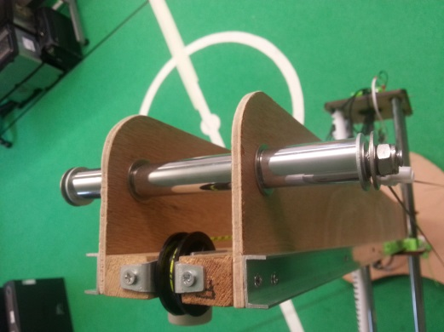

Figure 1.4 – Top view of mast with pulley.

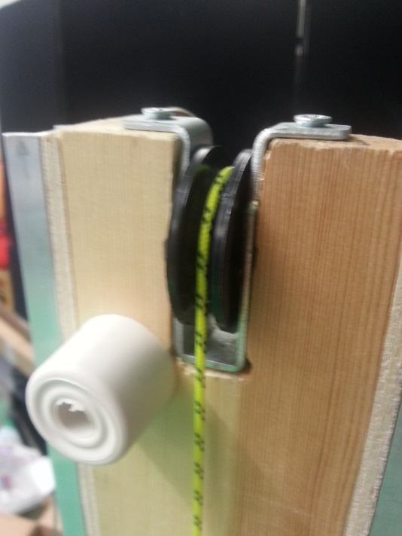

Figure 1,5 – Side view of mast with pulley.

An indentation 50mm deep and 18mm wide needs cutting for the pulley (measure the pulley size first), and two narrow pre-holes, e.g. 2.5mm diameter, need piercing along the axis of the bar to prevent it splitting when the pulley is screwed in in place using 30mmx 4mm wood screws. The fit of the pulley needs to be tight – you even may use glue to make sure – as this part can be subjected to loads of several 10’s of kilos.

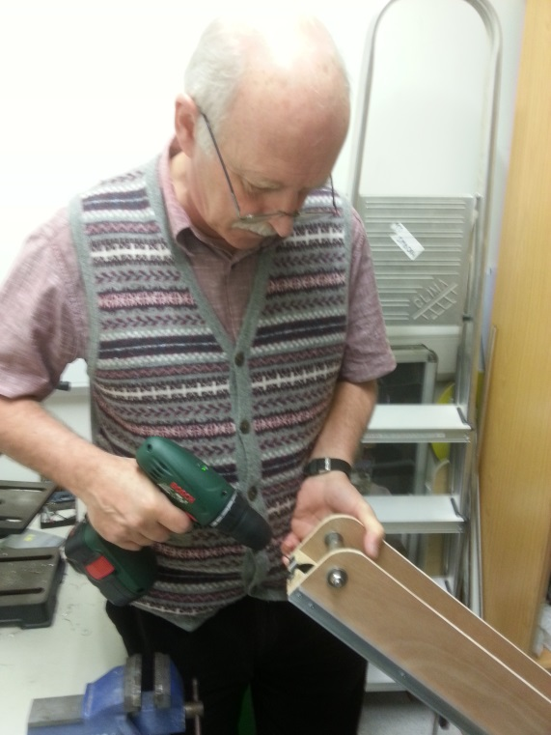

Figure 1.6 – Piercing pre-hole.

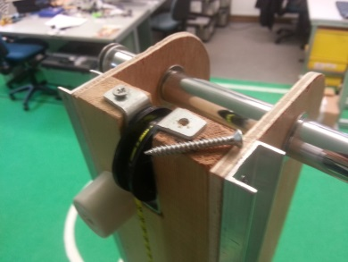

Figure 1.7 – Pulley holder with one screw removed.

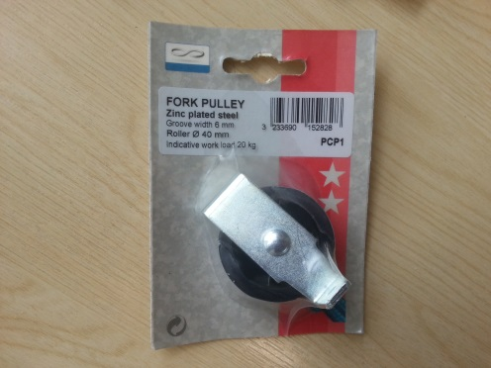

Figure 1.8 – Fork pulley.

# Rails

The rails are guides for the vertical motion of the arm and need to be solidly attached.

The rails are 10mm deep x 20mm wide x 1530 mm long u-shaped aluminium profiles attached to each side of the mast. They are flush with the top of the mast.

A series of 3 mm holes needs to be drilled in the centre of the rail. We made two holes close to each other at the top and the bottom, then holes separated by around 160mm.

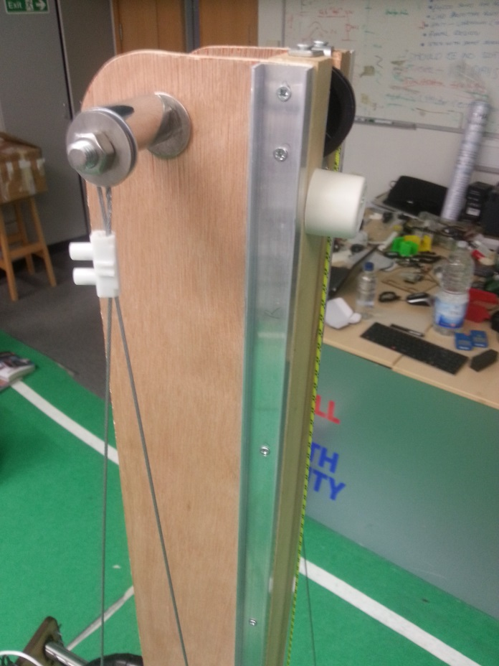

Figure 2.1 – Rails and support wire.

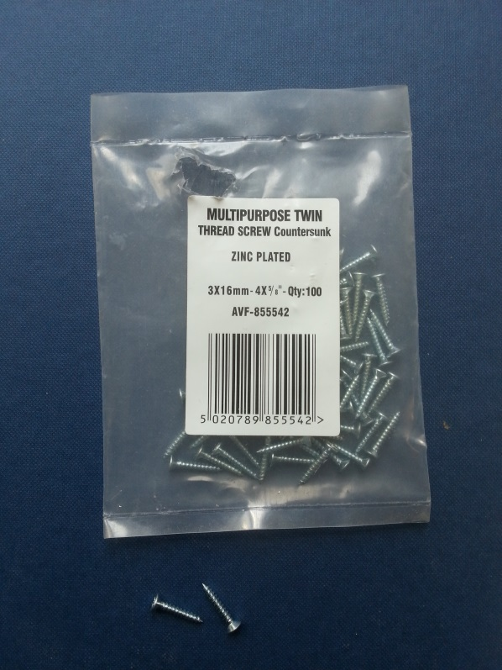

Figure 2.2 – Screws used for fixation.

# Cable holders

The mast is kept vertical through the use of cables similar to shrouds or stays used on sailing boats. This saves a lot of weight as the mast and its attachment at the bottom do not need to be very rigid.

At the top of the mast a 200mm long rod of M8 thread is passed through two 8mm holes in the side panels. The holes are 60mm from the front and 25mm from the top.

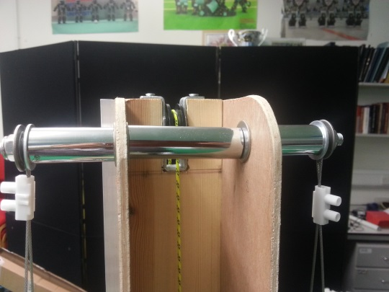

Figure 3.1 – Cable holder.



Figure 3.2 – Cable holder dimensions.

The cable is attached at some distance from the side panels to leave enough space for the arm to reach the top of its position range.

Penny washers are used to prevent damage to the wood and tubes of the same material as the arm are used as spacers. Smaller washers can be used to squeeze the cable, but are not really needed.

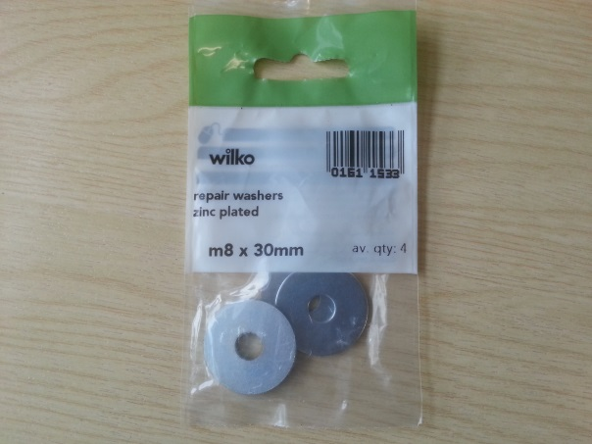

Figure 3.3 – Penny washers.

Attaching the cable. To start, cut two 350cm length of cables. Fold in half and pass around the top screw. Secure with a block connector size ?? on each side.

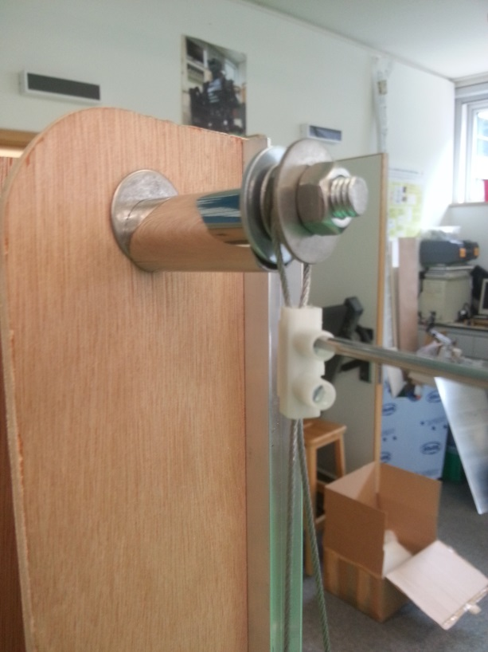

Figure 3.4 – Cable holder.

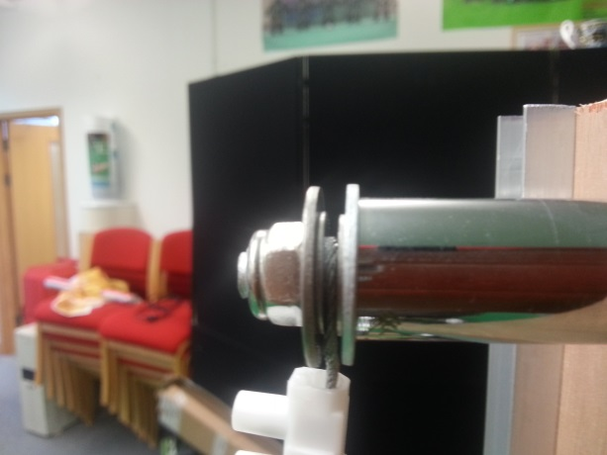

Figure 3.5 – Top of mast. Cable secured with block connector.

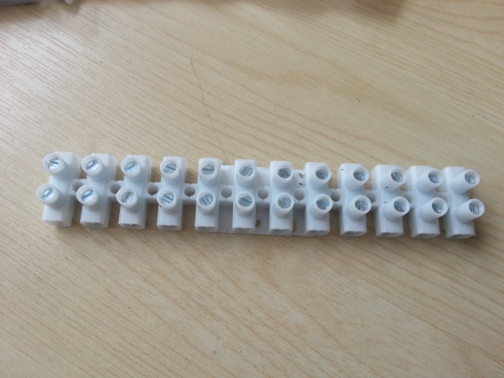

Figure 3.6 – Block connector.

Pass the bottom part of the cable in two blocks, in the furniture bracket, then back through the two blocks. This makes it secured with four screws. This is strong enough. Have the wing nut quite unscrewed, to leave a margin to tighten the cable if needed.

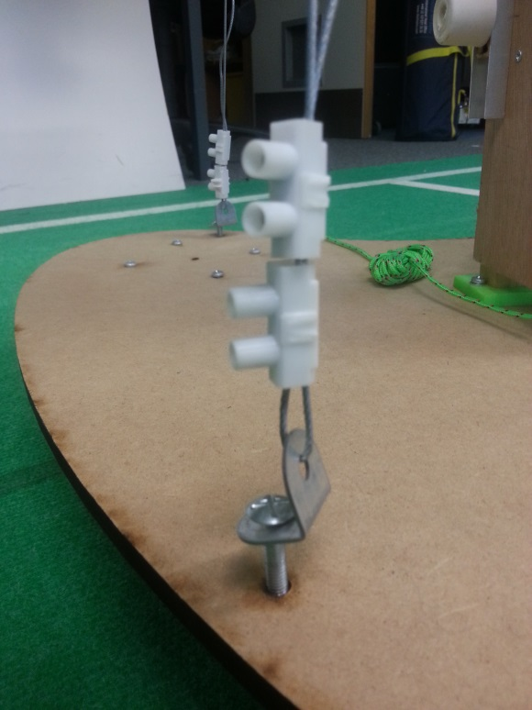

Figure 3.7 – Block connector used for securing wires.

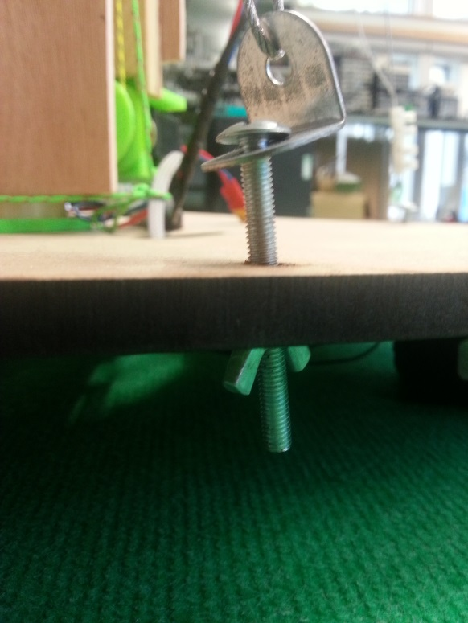

Figure 3.8 – Block connector used for securing wires.

The bottom part of the cable is attached to the base with adjustable tensioners made from four bolts, furniture brackets and wing nuts. It is useful to use a spirit level to ensure verticality in forward and lateral direction (Some smartphones have level measurement apps. These are precise enough). The cables do not need to be excessively tight.

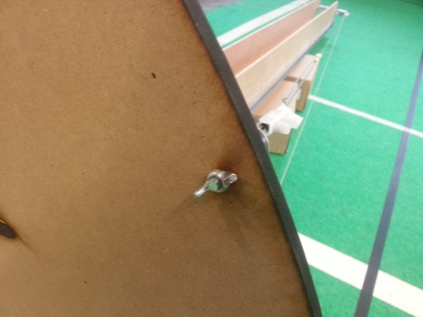

Figure 3.9 – Adjustable cable tensioners.

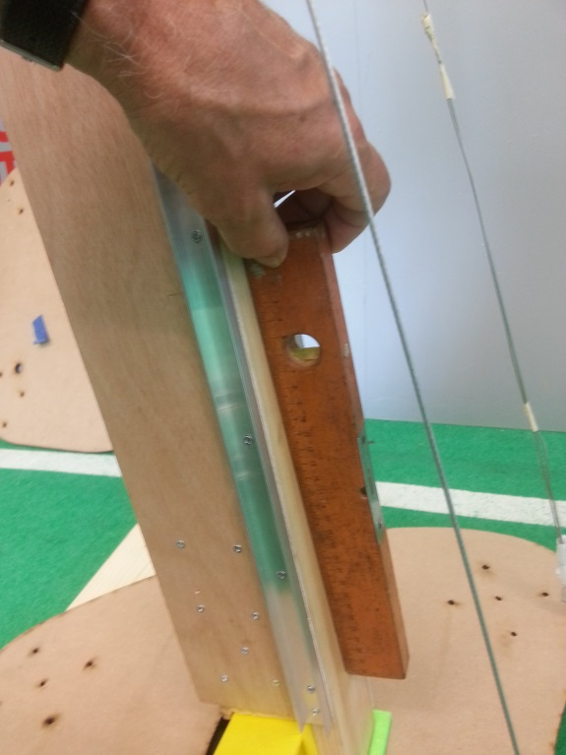

Figure 3.10 – Spirit level

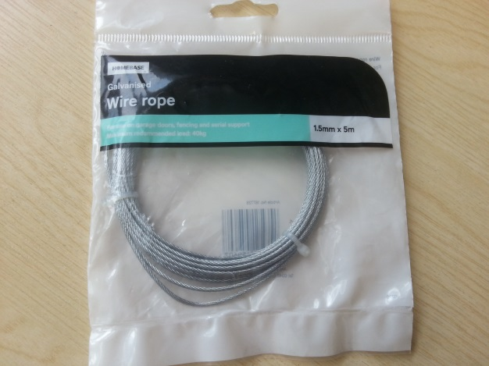

Figure 3.11 – Support wire.

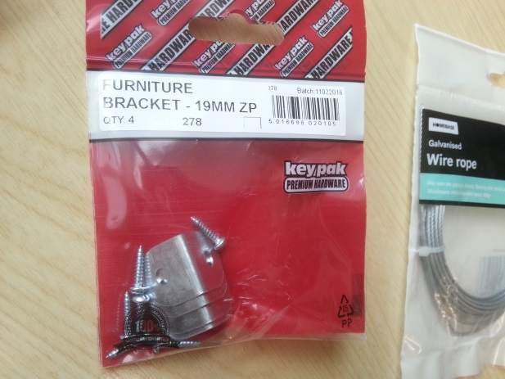

Figure 3.12 – Brackets for holding support screw.

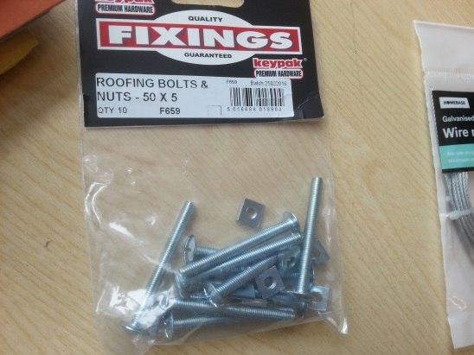

Figure 3.13 – Support screw.

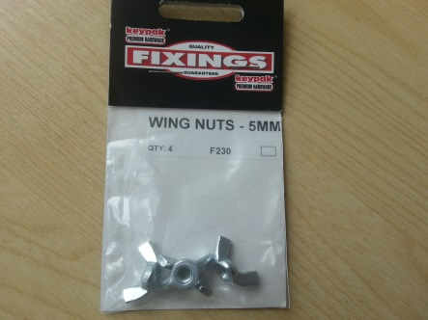

Figure 3.14 – Support screw wing nut.

# Mast base holder

The mast holder is a small piece of 3D printed PLA plastic (fig.2.1). It is used to keep the base of the mast in place (fig 2.2). It does not exert any force.

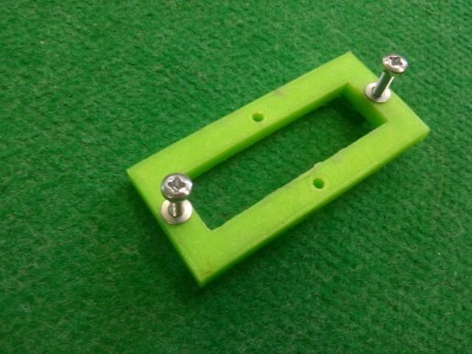

Figure 4.1 – Mast base plate.

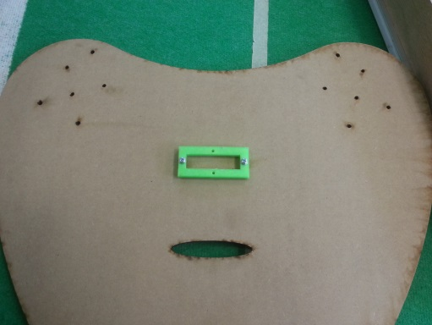

Figure 4.2– Mast base plate in position.

Files: MISSING?

## Arm movement limiters

Simple door stops are use at the top and the bottom of the mast to limit the displacement of the central plate of the arm. ANOTHER PIC OF BOTTOM AND TOP NEEDED

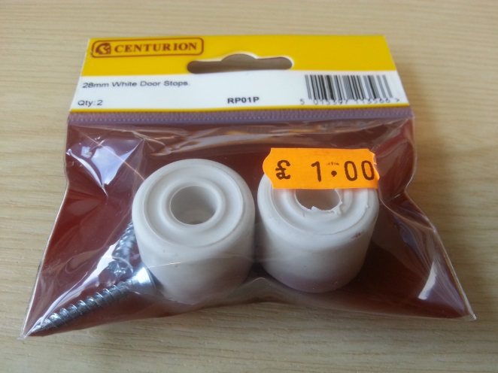

Figure 4.3 – Arm movement limiters.



Figure 4.4 – Top movement limiter.



Figure 4.5 – Bottom movement limiter.

# Lifting mechanism

The lifting mechanism uses a dual pulley mechanism. During the design, it was found that, when the central glider moves by 1 m, the back of the arm moves by 0.5m. The idea here is that a single pulley with two diameters (small diameter = 13mm and large diameter = 26mm) could generate the correct displacement of the arm. Initially a direct pulling mechanism was used with an RX-28 servo. This turned out to be overpowered most of the time. So, the current version uses an MX-64 servo and two additional pulleys to halve the force on both cables.

Note that the two cables act against each other and actually reduce the torque required from the servo. Some basic forces and torque calculations are given in the instructions for the arm.

The servo mount was initially the same as for the wheel, but had to be modified for the larger RX-64 servo. Note that we had to cut a M2.5 thread in the inside row of holes for the horn to use the same shaft design as for the RX-28 servo.



Figure 5.1 – Lifting motor and axle connector.

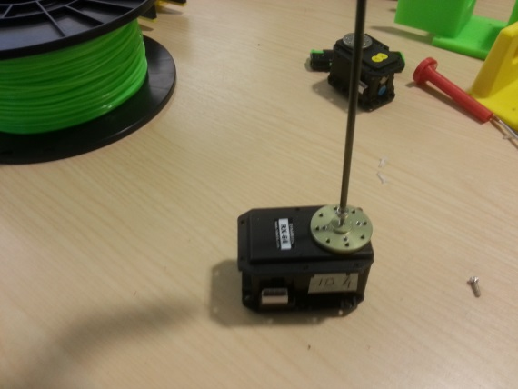

Figure 5.2 – Attached axle plate.

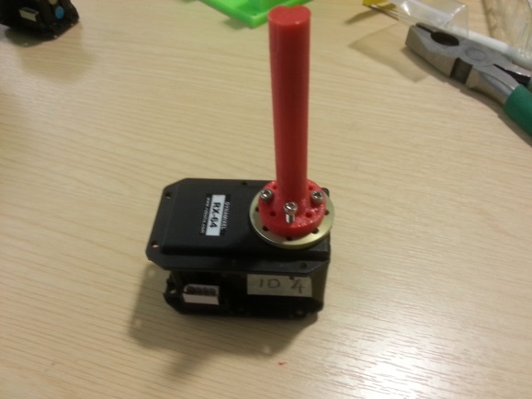

Figure 5.3 – Axle attached to motor.

Servo mount: design\v1\2-MAST\CAD\mx64-mount.FCStd

TO FIX FILE FROM DOMINIC: PART of PULLEY STUCK IN MOUNT

## Dual pulley

v1\2-MAST\CAD\dual-pulley.FCStd or dual-pulley.stp



Figure 5.4 – Ball bearing placement within motor holder.

Note that the pulley and shaft uses a single central ridge (as opposed to the new wheel shafts designed with two ridges to improve torque capacity).

## Shaft

v1\2-MAST\CAD\Coupler.stp



Figure 5.5 – Ball bearing placement within motor holder.

## Inner Ball Bearing

TO FIX –COUPLER-NEW.FCStd has wrong length – strange diameters.

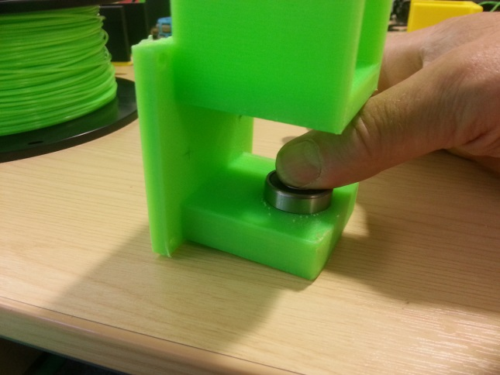

Figure 5.6 – Ball bearing placement within motor holder.

To hold the pulling force, two shaped pieces of wood are attached on each internal side of the mast with a good number of screws (seven in our illustration). Dimensions The shape of the lower part of the pieces is adapted to the shape of the servo mount, so that the pulling force acts evenly on the servo mount. The servo mount is attached with two screws to the central bar, but only loosely. The pulling force has to be taken by the two wooden par (two 3mm holes need to be drilled in the mount, unless the 3D printer design includes these holes)

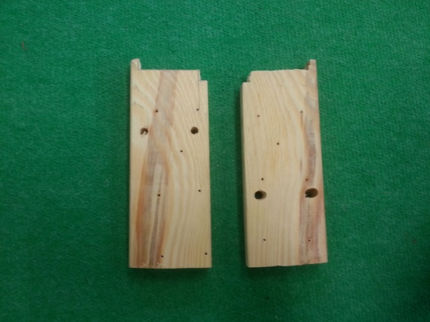

Figure 5.7 – Base internal side plates.

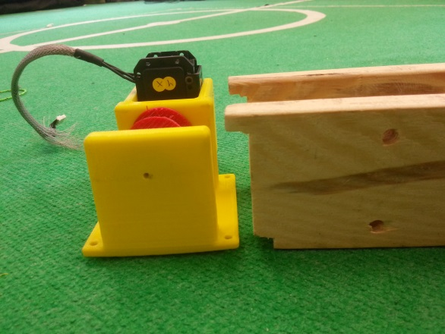

Figure 5.8 – Motor exact fit with internal plates.

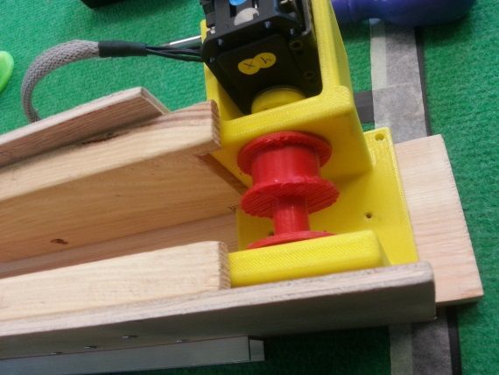

Figure 5.9 – Motor and internal plate positions.

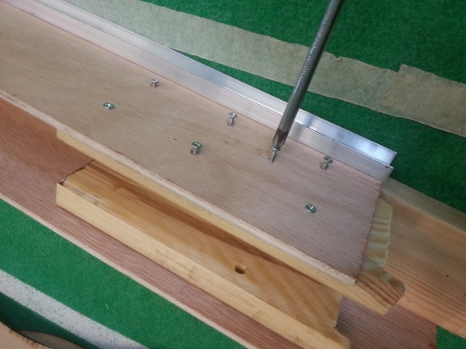

Figure 5.10 – Attaching side plates.

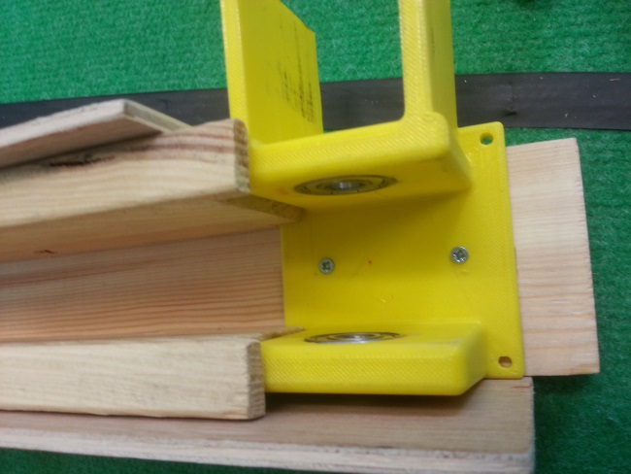

Figure 5.11 – Final positions.

**The pulley and lifting ropes will be installed once the arm is ready – See Arm instructions.**

1. The wood is sold as 25x75 but is planned and is actually smaller.